Viewing Point

📘 Definition
# Source: AI Source: Provided by: [Data Path: Persons Table -> ID Column: 1, Name_En Column: Motasem Essam] -> From: [ChatGPT] on [5/2/2026]
A Viewing Point is the position in 3D space from which a scene is observed. It is also called the eye point or camera position.
It represents the exact location of the observer (camera) in a 3D world.

📷 How the viewing point works
# Source: AI Source: Provided by: [Data Path: Persons Table -> ID Column: 1, Name_En Column: Motasem Essam] -> From: [ChatGPT] on [5/2/2026]
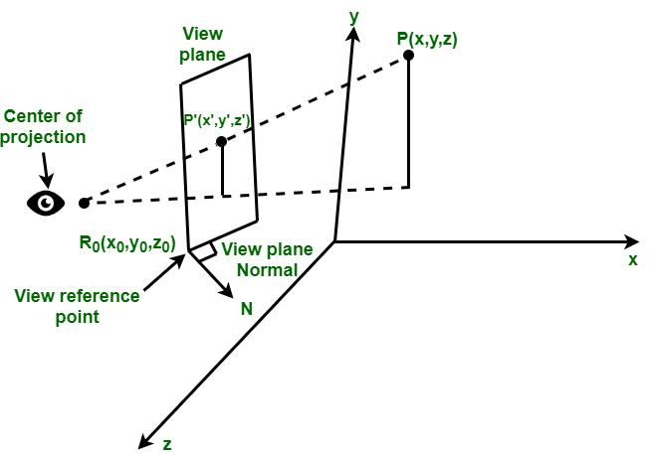
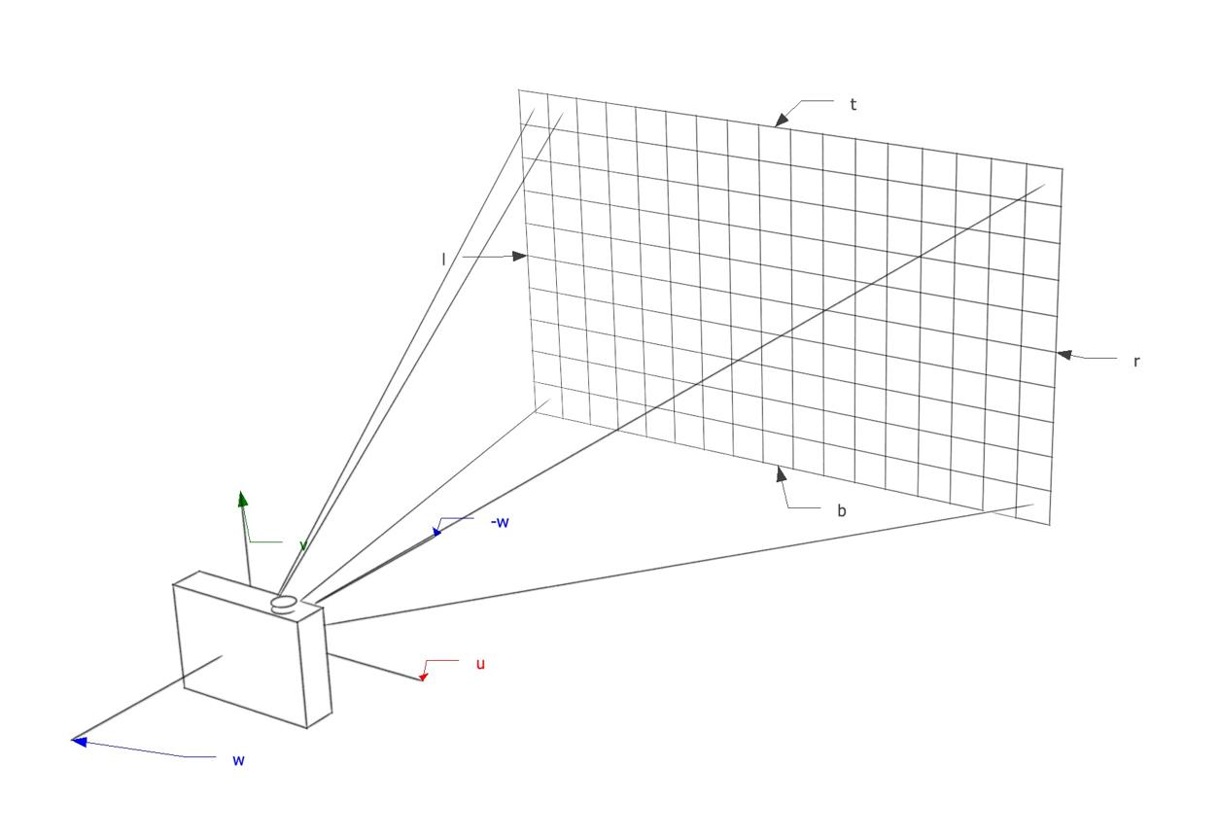
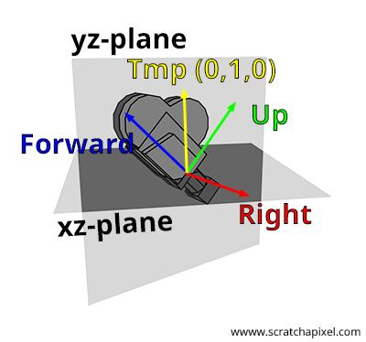
- The camera is placed at a specific point in 3D space
- It looks toward objects in the scene
- Everything is rendered based on this viewing position
- Changing the viewing point changes what you see

🧠 Simple example
# Source: AI Source: Provided by: [Data Path: Persons Table -> ID Column: 1, Name_En Column: Motasem Essam] -> From: [ChatGPT] on [5/2/2026]
Think of:
- 👁️ Your eyes when looking at a room
- 📷 A camera placed at a certain spot taking a photo
Where you stand or place the camera = viewing point

🎮 In computer graphics
# Source: AI Source: Provided by: [Data Path: Persons Table -> ID Column: 1, Name_En Column: Motasem Essam] -> From: [ChatGPT] on [5/2/2026]
The viewing point is used to:
- 🎮 Define the player’s position in a game world
- 🎬 Set camera position in animation and movies
- 🧑‍💻 Control perspective in 3D modeling software
- 📐 Work with viewing frustum and projection

⚙️ Key features
# Source: AI Source: Provided by: [Data Path: Persons Table -> ID Column: 1, Name_En Column: Motasem Essam] -> From: [ChatGPT] on [5/2/2026]
- 📍 A single point in 3D space
- 👁️ Acts as the observer’s position
- 🎯 Determines what is visible
- 🔄 Changing it changes the entire view

🚀 In short:
# Source: AI Source: Provided by: [Data Path: Persons Table -> ID Column: 1, Name_En Column: Motasem Essam] -> From: [ChatGPT] on [5/2/2026]
Viewing Point = the position of the camera or eye in a 3D scene from which everything is observed.

